21 AIM:- Develop a system using UML for Hospital Management System. The central system should manage patients’ and doctors’ appointments and case details. Also, include medical prescriptions and consultation fee details.

STATE-CHART DIAGRAM:

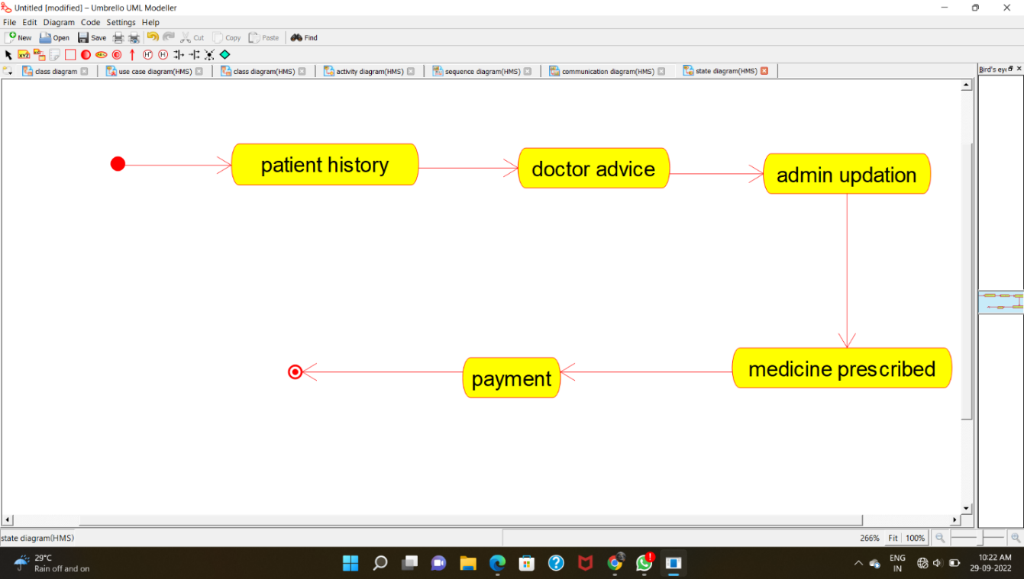

COMPONENT DIAGRAM: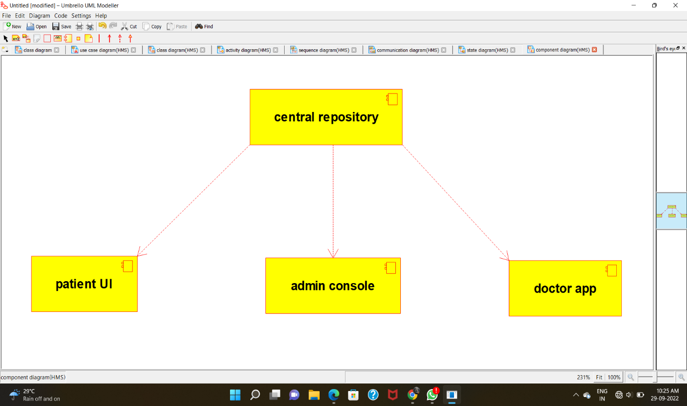

DEPLOYMENT DIAGRAM:

